#### 

ER33-TP-0146

Revision-Baseline

**EFFECTIVE DATE: 6/27/2016**

**George C. Marshall Space Flight Center**

**Marshall Space Flight Center, Alabama 35812**

**Fast-Aero Multiport Valve (MPV) Test**

**Engineering Directorate**

**Propulsion Systems Department**

**Propulsion Component Design and Development Division**

**Valves, Actuators, and Ducts Design & Development Branch**

**ER33**

**Component Development Area**

**DOCUMENT HISTORY LOG**

|  |  |  |  |
| --- | --- | --- | --- |
| **Status**  **(Baseline/**  **Revision/**  **Canceled)** | **Document**  **Revision** | **Effective**  **Date** | **Description** |
| Baseline | - | 6/27/2016 |  |

**APPROVALS**

**Gustavo A. Martinez 6/27/2016**

**ER33 Document Originator Date**

**ER33 CDA Lead Date**

**ER33 Team Lead Date**

**QD12 Industrial Safety Date**

**ER33 Test Personnel Date**

**TABLE OF CONTENTS**

1. scope 4

2. purpose 4

3. test description 4

4. reference documents 6

5. safety precautions 6

6. test hardware description 7

7. initial test set-up 13

8. Run Tank Filling 15

9. test Runs procedures 21

10. Run tank draining 25

11. emergency operations 26

# scope

This procedure defines the test requirements to test the Fast-Aero Multiport Valve (MPV). The primary objective is to investigate flow Characteristics, distribution, and leakage of the valve using LN2. This valve uses parts manufactured using SLM and this test will exercise those parts under pressure in water and in LN2.

# purpose

The purpose of this test procedure is to ensure that the Fast-Aero Multiport Valve (MPV) is tested in a safe and controlled way. All testing shall be performed at the Component Development Area (CDA) located at Building 4656.

# Test description

Testing of the valve will be under separate pressurized and flow rate test conditions. The MPV will start out at 100% closed whiles LN2 is flowed to flood the downstream side of the MPV to chill in the flow line. HOV-1 and … will remain open during chill in. A series of tests will occur with the valve being cycled from fully-closed-to-fully-open-to-fully-closed under pneumatic actuation by a Series CVQ Pneumatic Actuator. Another series will occur under various dP’s and flow rates with the valve being cycled from fully-closed to fully-open under pneumatic actuation.

Testing of the MPV valve assembly is to take place in different sequences:

1. The valve will be hydrostatically proof tested per the standard CDA procedures. The valve will have successfully completed proof testing, and the test results will be on file prior to beginning this test. Pretest internal and external leak checks will also be performed. The valve will be leak checked to confirm build and actuator setup. This test will be performed using the standard CDA procedures and is not part of this procedure. The test will be conducted using 25 to 50 psig GN2 with the valve commanded closed. The valve will be checked for external leakage using soap solution, and internal leakage using a bubble-o-meter. Leakage in excess of zero bubbles per minute shall be dispositioned by the test requestor and/or test engineer prior to proceeding with subsequent tests.
2. Pretest baseline stroke will be performed. With zero pressure on the valve and the valve pneumatically actuated. The valve will be cycled from fully-closed-to-fully-open-to-fully-closed; a minimum of 3 times while recording data. This test is performed to verify valve health and actuator function prior to water and LN2 flow testing.

1. During initial chill in of the valve, internal leakage will be checked using bubble-o-meter, or low flow flowmeter. Also, with the valve chilled against the upstream side, an LN2 internal leak check will be made at 50 +/-25 psig prior to and after final test runs. The MPV will be commanded fully-closed for internal leak checks. Internal leakage testing will occur with the MPV outlet ports capped off or the tube end fittings plugged.
2. For the water flow test, the upstream side of the MPV will be flooded with the MPV valve held closed and the tank regulated to a pressure of 50 to 100 psig and then the MPV opened to flow water through the outlet ports and data recorded.
3. For the LN2 testing, LN2 will be flooded to the upstream side of the MPV to chill in the inlet line up to the valve whiles the MPV is held closed. During the first chill in 50 to 100 psig pressure will be generated upstream down and through the bleed valve—HOV 1.
4. With the MPV fully-closed and LN2 at various inlet pressures, the MPV will be taken to the gauge pressure defined in the test request. Once the target pressure has been established, the MPV will be cycled between full-closed-to-full-open-to-full-closed at a rate and duration defined in the test request. Maximum MPV inlet test pressure for this sequence will be 1500 psig. Actuator pneumatic pressure range for this test will be 50 to 100 psig. Sequence 3 will be repeated after flow testing in sequence 6.

**Table 1 – Pressure Drop Test Conditions**

|  |  |  |
| --- | --- | --- |
| Inlet Pressure (psig) +/-10% | Outlet Pressure (psig) +/- 10% | Estimated Full Open Flowrate (GPM) |
| 50 |  |  |
| 100 |  |  |
| 250 |  |  |
| 500 |  |  |
| 750 |  |  |
| 1000 |  |  |
| 1500 |  |  |

Density LN2 = 50.38 lb/ft^3 Density Water = 62.4lb/ft^3

# reference documents

96M19158 CDA Fluid Schematic

MWI 1700.2C System Safety Program

MPR 1840.2C MSFC Hazard Communication Program

MPR 8730.5 Control of Inspection, Measuring, and Test Equipment

MWI 8710.1 “Inspection and Certification Process for Pressure Vessels and Systems (PVS)”

MPR 8715.1 Marshall Safety, Health, and Environmental (SHE) Program

MWI 8715.15E Ground Operations Safety Assessment Program

MPR 8823.2 Pressure Systems Guidelines and Certification Requirements

ANSI 13.1 Schemes for the Identification of Piping Systems

ASME B31.1 Power Piping Code

ER33-PLAN-CDA Component Development Area Operation Plan

Test Requirements MFV Full Flow Test Requirements

# safety precautions

The **Test Article** **MPV** valve is customer supplied and has been proofed to 3000 psig and documentation provided by the customer. This test will occur via the North West Bunker using the 500 gallon run tank system at CDA. This test is not designed to test component structural integrity. All personnel operating CDA fluid systems shall be certified for those operations per MWI 341~0.1.

Use extreme caution when conducting pneumatics and/or venting operations during tests. Use approved personal protective equipment (PPE):

1. Eyes: Safety glasses shall be worn when venting or purging systems.
2. Ears: Earplugs or earmuffs shall be used where excessive noise levels occur near filling and venting operations.
3. Hands: When handling test fixtures, protective gloves shall be worn.

Do not remove a test unit from a pressurized line. Test set-up provides vent valve to bleed pressure from the test article. Verify that the test article is vented prior to removal.

Only personnel certified to work on high pressure systems are allowed access to the test area while facility systems are pressurized. Personnel may only enter the test area with permission by the Test Engineer. All personnel shall wear approved personal protective equipment for the operation being performed as defined below:

General Operations:

|  |  |
| --- | --- |
| Eyes | Safety glasses with side shields shall be worn during fabrication of metallic components such as tubing and panels. Visiting personnel shall wear safety glasses. |
| Feet | Closed-toe shoes that cover the top of the foot or boots with trouser legs extended over the top of the boot shall be worn during operations. Safety shoes shall be worn while performing lifting operations or if in areas where lifting operations are being performed. |
| Body | Cuff-less long trousers worn outside boots or over shoes shall be worn. |
| Ears | Each occupant shall carry earplugs or earmuffs. Venting operations inside the CDA or in other areas within the building occur with very short notice. |
| Head | A hard hat shall be worn if lifting operations are being performed in the high bay. |

Cryogenic & Pressurized Systems (> 150 psig):

|  |  |
| --- | --- |
| Eyes | Safety glasses with side shields shall be worn. Visiting personnel shall wear safety glasses with side shields. Full Face Shields shall be worn when transferring cryogen. |
| Hands | Gloves shall be worn to prevent injury to hands from cryogenic burns. Clean leather gloves shall be worn if more protection is needed. |
| Feet | Closed-toe shoes that cover the top of the foot or boots with trouser legs extended over the top of the boot shall be worn. |
| Body | Long-sleeved clothing, cuff-less long trousers worn outside boots or over shoes shall be worn. |
| Ears | Earplugs or earmuffs shall be used when venting gases. |

If any personnel injury occurs, the following is offered as a guide:

* Isolate or remove the hazard from the area.
* Move injured personnel only if necessary to prevent further injury.
* Call for medical help.
  + Medical/Ambulance 911
  + Fire Department 911
  + Security 544-4357
  + Environmental Incident 911
  + Utilities 544-3919
  + Blood Cleanup 544-4000
  + Medical Center 544-2390
  + Safety Hotline 544-0046

# test hardware description

This section defines the test hardware to be used during the tests.

1. 1. Mechanical Systems
      1. The flow system used for this test series will utilize the 500 gallon tank system at 4656 with LN2 flow media. The run tank has 500 gallon capacity, 2900 psig capability. **RV-119,** set to protect the test article, is set at **2750 psig** and all testing will use **1500 psig** maximum supply pressure. Valves are manipulated either manually prior to pressurized system or pneumatically for those requiring manipulation while the system is pressurized.
      2. The test article MPV valve is a pneumatically actuated linear position valve designed for cryogenic propellant. It has a stroke of ~2.4 inches. The valve body is manufactured from additively manufactured Inco 718 while several of its internal parts are either commercial or traditionally machined parts. The MPV has one (2-inch) inlet and 48-outlet ports.

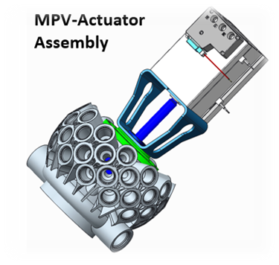 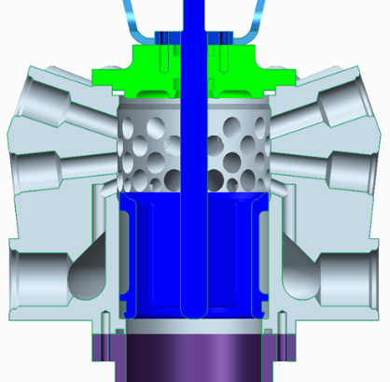

Test Article MPV and Actuator

* + 1. Instrumentation
    2. PWG Systems’ TopCAT2008 is a general-purpose data acquisition hardware and software package designed to control the National Instruments TMSCXI Data Acquisition Hardware. This software is designed to operate and control SCXI Chassis modules connected to an E or M Series Data Acquisition Cards or an SCXI-1600 Data Acquisition Module. Modules include: SCXI-1520 (8-Channel ¼, ½, Full Bridge Strain Gage Module), SCXI-1102 (32- Channel TC Input Module (2-Hz BW), SCXI-1160 16-Channel SPDT Relays.
    3. All data acquisition and control will be provided by a National Instruments SCXI Chassis and LabView® software running a computer. During the tests, the data acquisition and control equipment as well as the Test Conductor will be located in Room 103 of the Component Development Area (Building 4656). A 24 VDC power supply will provide power to the SOVs and excitation power to the pressure transducers. A 9 VDC power supply will provide power to the relay

**Figure 1a. Test Set-up**

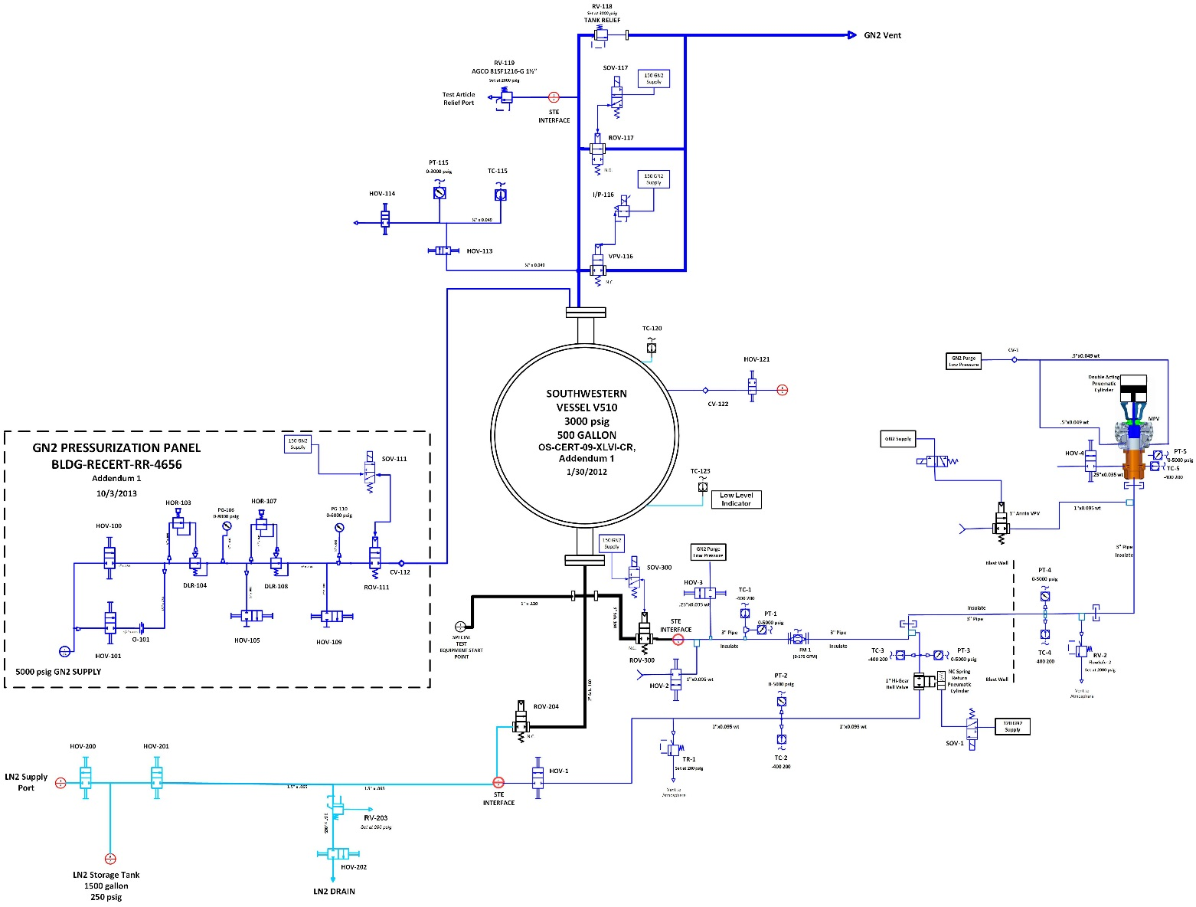

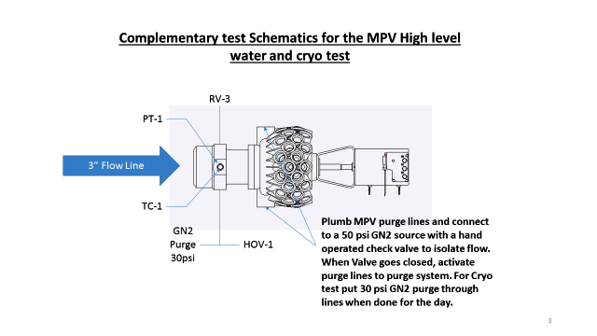

**Figure 2 GN2 Distribution Panel**

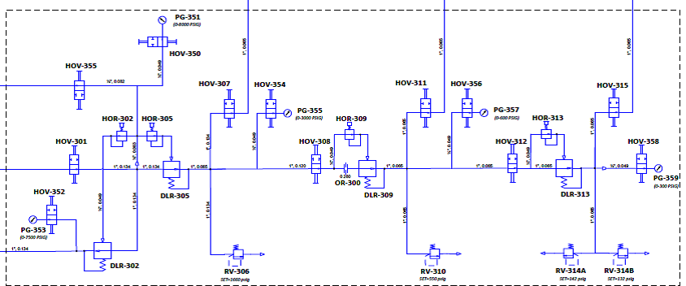

**Figure 3 Liquid Nitrogen Storage System**

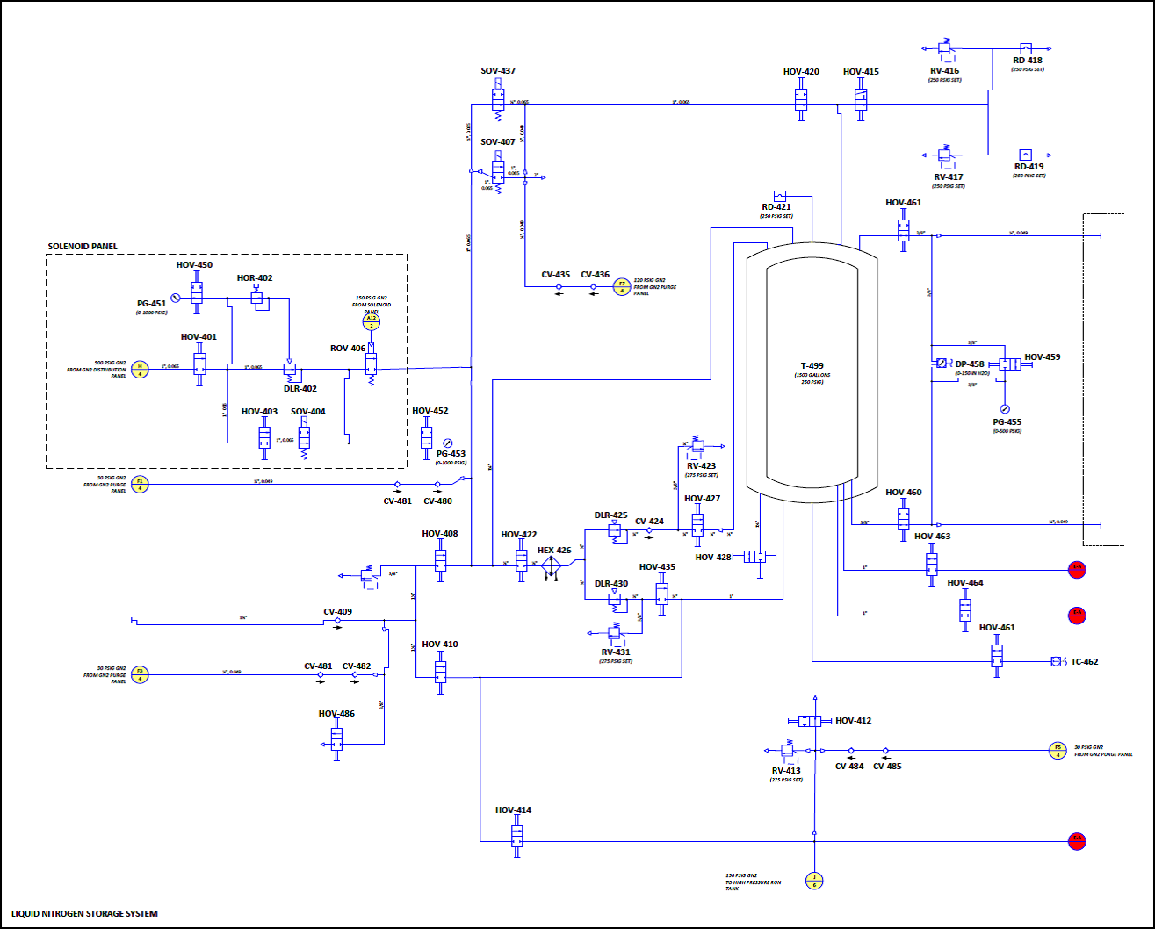

# 7.0 initial test set-up

This section defines the steps to establish the initial conditions for the LN2 system.

The zero state conditions for the LN2 and GN2 systems are shown in the 3 below.

Table 3: Test System Zero State Conditions

|  |  |  |
| --- | --- | --- |
| **Component ID** | **Description** | **State** |
| **HOV-100** | High Flow Isolation valve | Closed |
| **HOV-101** | Low Flow Isolation Valve | Closed |
| **HOR-103** | First Stage Hand Regulator | Closed |
| **DLR-104** | First Stage Dome Loader | Closed |
| **HOR-107** | Second Stage Hand Regulator | Closed |
| **DLR-108** | Second Stage Dome Loader | Closed |
| **HOV-105** | First Stage Isolation Valve | Closed |
| **HOV-109** | Second Stage Isolation Valve | Closed |
| **ROV-111** | Main GN2 Isolation Valve | Closed |
| **HOV-113** | Instrumentation Bleed Valve | Closed |
| **HOV-114** | Instrumentation Bleed Valve | Closed |
| **VPV-116** | GN2 Vent Valve | Closed |
| **ROV-117** | GN2 Vent Valve | Open |
| **HOV-121** | 150 PSIG GN2 Purge Isolation Valve | Open |
| **HOV-200** | Fill Isolation Valve 1 | Closed |
| **HOV-201** | Fill Isolation Valve 2 | Closed |
| **HOV-202** | Vent/Drain Valve | Open |
| **VPV-204** | Main Tank Isolation Valve | Closed |
| **ROV-300** | Main Test Article Isolation Valve | Closed |
| **ROV-400** | Alternate Test Article Isolation Valve | Closed |
| **MPV** | Test Article Valve | Closed |
| **HOV-1** | Flow Meter Bypass Valve | Closed |
| **HOV-2** | Run Line Drain Valve | Closed |
| **HOV-3** | Run Line Purge Valve | Closed |
| **HOV-4** | MPV Bleed Valve | Closed |
| **HOV-6** | MPV Purge Valve | Closed |
| **ROV-5** | Flow Meter Bypass Line Isolation Valve | Closed |
| **VPV-1** | MPV Vent Valve | Closed |

Component Nominal Conditions

# initial test set-up

|  |  |  |  |
| --- | --- | --- | --- |
| Step Number | Description | Verification | Notes |
| 7.1.1 | Verify test personnel are trained and certified to operate/maintain cryogenic systems. |  |  |
| 7.1.2 | Lock or Barricade All Access Points to the Test Control Area |  |  |
| 7.1.3 | Walk Down the System and Verify Proper Initial State all Components. Verify no relief valves are mounted such that personnel are affected by discharge. |  |  |
| 7.1.4 | Notify All Test Personnel the Potential for Loud Venting Exists. Test Personnel shall utilize appropriate PPE. |  |  |
| 7.1.5 | Verify Emergency stop functionality |  |  |
| 7.1.6 | Verify that live feed camera is operational |  | Camera is set up for live video feed and recording of testing |
| 7.1.7 | **Clear All Non-Essential Test Personnel from the Control Area. All Access Will Be Controlled through the Test Control Room** |  |  |

# 7.2 Initial GN2 Purge (~30 psi GN2 purge)

|  |  |  |  |
| --- | --- | --- | --- |
| Step Number | Description | Verification | Notes |
| 7.2.1 | Actuate MPV to 100% Open |  |  |
| 7.2.2 | Verify ROV-300 is closed. Verify ROV-204 is closed. |  | Isolate test article and LN2 feed lines |
| 7.2.3 | Open VPV-1 |  |  |  |
| 7.2.4 | Open ROV-5, HOV-1, HOV-202 |  | Purging test article and LN2 feed lines |  |
| 7.2.5 | Open HOV-3 |  | Start Purge |  |
| 7.2.6 | When lines purged, Close HOV-202, HOV-1, ROV-5 |  | Traps GN2 in LN2 feed line and FM bypass line |  |
| 7.2.7 | Close HOV-3 |  | Stops test article feed line purge |  |
| 7.2.8 | Open HOV-4 and HOV-6 |  | Initiates purge through test article’s purge valve |  |

# 

# 8. LN2 Tank Procedures

This section defines the steps to establish fill and chill procedures for the LN2 run tank and draining the tank at the conclusion of the test.

# sEQUENCE 4 Ln2 RUN tank Fill Procedures

|  |  |  |  |
| --- | --- | --- | --- |
| Step Number | Description | Verification | Notes |
| 8.1.1 | Verify Test leg in purge state (7.2.1-7.2.8) |  |  |
| 8.1.2 | Close ROV-300, Close ROV-111, Close HOV-1 |  | Isolate the tank supply |
| 8.1.3 | Open HOV-113 to Expose PT-115/TC-115 to tank environment |  |  |
| 8.1.4 | Verify HOV-114 is Closed |  |  |
| 8.1.3 | Regulate HOR-103/HOR-107 on DLR-104/108 to 0 Psig |  | Zero out supply pressure |
| 8.1.4 | Open HOV-414 , Open HOV-412 to chill transfer line |  | Chill transfer line. |
| 8.1.5 | Close HOV-412 when transfer line chilled |  | Ready tank fill |
|  | This space intentional |  | This space intentional |
| 8.1.6 | Verify Close ROV-111, Verify Close ROV-300, Verify Close VPV-204  Verify Close HOV-201 |  |  |
| 8.1.7 | Open VPV-116 to vent tank, then Open ROV-117 |  | **(CAUTION: LOUD VENTING!)**   Loud Venting if tank pressurized- Tank Vents to ambient |
| 8.1.8 | Close VPV-116 |  |  |
| 8.1.9 | Verify/ Prepare Dewar For LN2 transfer 8.1.2 – 8.1.5 |  |  |
| 8.1.10 | Open HOV-201, Open VPV-204 |  | Initiates tank filling |
| 8.1.11 | Continue Fill run tank to full |  |  |
| 8.1.12 | To refill or top off, repeat 8.1.6 – 8.1.12 |  |  |

# 9. TEST RUNS

This section defines the test runs to be performed.

# Sequence 5 Testing – Internal Leak Check

|  |  |  |  |
| --- | --- | --- | --- |
| Step Number | Description | Verification | Notes |
| 9.1.1 | Verify ROV-300, ROV-204, ROV-111, and HOV-1 are Closed. Verify ROV-117 and VPV-116 is Open, and tank is full |  | Tank is Full |
| 9.1.2 | Adjust HOR-103/HOR-107 on DLR-104/DLR-108 to provide 0 psig supply pressure read on PG-110 |  | Upstream ROV-111 at 0 psig |
| 9.1.3 | Verify PT-1,PT-2, are at 0 psig |  |  |
| 9.1.4 | Verify the MPV Test Article set to proper run position |  | Fully Closed - Refer Test Request |
| 9.1.5 | Hook up Tygon tubing to HOV-4 outlet and route to bubble meter or flowmeter |  | Leak flow hook up |
| 9.1.6 | **Verify No Personnel Inside Bunker** |  | Clear all persons from inside bunker |
| 9.1.7 | Open HOV-4 |  | Bleed valve Open |
| 9.1.8 | Close VPV-1 |  | Isolates test leg outlet |
| 9.1.9 | Open ROV-5 |  |  |
| 9.1.10 | Open HOV-1 |  | Allow flow of LN2 under tank head through flow meter bypass |
| 9.1.11 | Open HOV-201 |  |  |
| 9.1.12 | Begin Recording Data |  |  |
| 9.1.13 | Witness leakage through bubble meter as chill in occurs up to MPV inlet |  | Chill in up to MPV inlet |
| 9.1.14 | Monitor TC-1, TC-3, and TC-4 to ensure LN2 reaches upstream of ROV-300 |  | Control VPV-1 if needed |
| 9.1.15 | Close ROV-5 when liquid TC-1 reads LN2 temperature |  |  |
| 9.1.16 | Open ROV-300, Open ROV-204 |  | Chill run line |
| 9.1.17 | Ensure run line and tank are full |  |  |
| 9.1.18 | Close ROV-204 when LN2 is seen at VPV-1 outlet |  | Isolate LN2 dewar |
| 9.1.19 | Open HOV-202 |  | Drains the bypass and dewar fill line |
| 9.1.20 | Verify PT-2 is reading 0 psig and note temperature of TC-2 |  | Line is drained |
| 9.1.21 | Close HOV-1 |  |  |
| 9.1.22 | Close HOV-202 |  |  |

# 9.2. Sequence 6 Testing – Cryo (LN2) flow TEST

|  |  |  |  |
| --- | --- | --- | --- |
| Step Number | Description | Verification | Notes |
| 9.2.1 | **Verify No Personnel next to Test Article or Inside Bunker** |  | Clear all persons from inside bunker and around Test Article |
| 9.2.2 | Close VPV-1 |  |  |
| 9.2.3 | Verify Test Article set to proper initial run position |  | Refer Test Request, **100% Closed** |
| 9.2.4 | Close ROV-117 and VPV-116 |  | Ready to pressurize |
| 9.2.5 | Verify 0 psig on PG-110 and PT-115 |  |  |
| 9.2.6 | Open ROv-111 |  |  |
| 9.2.7 | Adjust HOR-103/DLR-104 and HOR-107/DLR-108 to provide test pressure per test request |  |  |
| 9.2.8 | Verify pressure per test request on PT-115/PT-1/PT-5 |  |  |
| 9.2.9 | Begin Recording Data |  |  |
| 9.2.10 | Cycle the MPV from 100% to 100% Open at the slew rate requested |  | **BEGIN RUN** |
| 9.2.11 | Close the test article |  | **END RUN** |
| 9.2.12 | Stop Recording Data |  |  |
| 9.2.13 | Adjust HOR-103/DLR-104 and HOR-107/DLR-108 to provide next test pressure per test request |  |  |
| 9.2.14 | Repeat ____ - ____ |  |  |
| 9.2.15 | If Tank needs filling proceed to ____ |  |  |
| 9.2.16 | Close ROV-111 |  |  |
| 9.2.17 | Adjust HOR/103/DL-104 and HOR-107-DLR-108 to provide 0 psig |  |  |
| 9.2.18 | Verify 0 psig using PG-110 |  |  |
| 9.2.19 | Open VPV-116 to vent tank |  |  |
| 9.2.20 | Verify 0 psig using PT-115/PT-1/PT-4/PT-5 |  | Vented system |
| 9.2.21 | Proceed to Section 8.1 LN2 Tank Fill Procedures |  | Adjust VPV-1 as needed |
|  | **End of Testing** |  | **End of Testing** |

# ln2 run tank vent and drain operations

# LN2 RUN TANK VENT AND DRAIN OPERATIONS

|  |  |  |  |
| --- | --- | --- | --- |
| Step Number | Description | Verification | Notes |
| 10.1.1 | Close HOV-100 to isolate the GN2 Pressurization System. |  | Remove system pressure |
| 10.1.2 | Close ROV-111 to isolate the GN2 Pressurization System |  | Isolate tank supply |
| 10.1.3 | Slowly Open VPV-116 to Vent LN2 Tank to 0 psig **(CAUTION: LOUD VENTING!)** Then Open ROV-117 |  | **(CAUTION: LOUD VENTING!)** |
| 10.1.4 | Regulate HOR-103/HOR-107 on DLR-104/DLR-108 to 0 psig as read on PG-106/PG-110 |  |  |
| 10.1.5 | Verify 0 psig on PT-115/PT-1/PT-5 |  |  |
| 10.1.6 | Actuate the MPV to 100% Open |  |  |
| 10.1.7 | Close ROV-300 |  |  |
| 10.1.8 | Open HOV-2 |  | Drain System |
| 10.1.9 | Open HOV-3 |  | Start run line purge |
| 10.1.10 | Open HOV-4 |  | Start MPV purge |

# 11. emergency operations

This section defines operations to be undertaken should an emergency arise during testing.

A. Emergency Phone Numbers

* + Medical/Ambulance 911
  + Fire Department 911
  + Security 911
  + Environmental Incident 911
  + Utilities 544-3919
  + Medical Center 544-2390
  + MSFC Safety Office 544-0046

B. Personnel Injury

If a personnel injury occurs during the execution of this procedure, the Test Conductor must determine whether the injured person is currently safe from test facility hazards so that medical attention may be sought immediately, or if facility systems need to first be shut down to ensure safety. Regardless, immediately call 911 so that medical assistance can be on their way. If facility systems need to be shut down first, before attending to the injured person, then execute Section 11.1.1-11.1.4 before continuing with this section.

1. ( ) Call 911 for medical assistance.

2. ( ) Isolate or remove the hazard from near the injured person if appropriate to prevent additional injuries.

3. ( ) Do not move the injured person unless it is necessary to prevent further injury.

C. Loss of Electrical Power

If a loss of electrical power occurs during the execution of this experiment, the system will go to safe state with vents going open. Electrical power is re-established; the Test Conductor will assess where to resume execution of the test procedure.

D. Emergency Shutdown

Refer to Section 7 of ER33-PLAN-CDA, “Component Development Area Operation Plan” for locations of emergency gas shutoffs.

# emergency operations for test article Anomoly Shutdown

|  |  |  |  |
| --- | --- | --- | --- |
| Step Number | Description | Verification | Notes |
| 11.1.1 | Close ROV-111 to isolate tank from GN2 Pressurization |  |  |
| 11.1.2 | Open VPV-116 to remove pressure from Water Run Tank, then Open ROV-117 (LOUD VENTING) |  | **(CAUTION: LOUD VENTING!)** |
| 11.1.3 | Close ROV-300 to isolate test article from water/LN2 Run Tank |  |  |

# emergency operations for Loss of Power

|  |  |  |  |
| --- | --- | --- | --- |
| Step Number | Description | Verification | Notes |
| 11.2.1 | ROV-111 will fail Closed to isolate the Run Tank from the Pressurization Source |  |  |
| 11.2.2 | ROV-117 will fail Open to vent the Run Tank |  |  |
| 11.2.3 | ROV-300 will fail closed |  |  |
| 11.2.4 | SOV-1 will fail open |  | Normally open valve |